**Exponential model word problems**

**EXAMPLE #1**

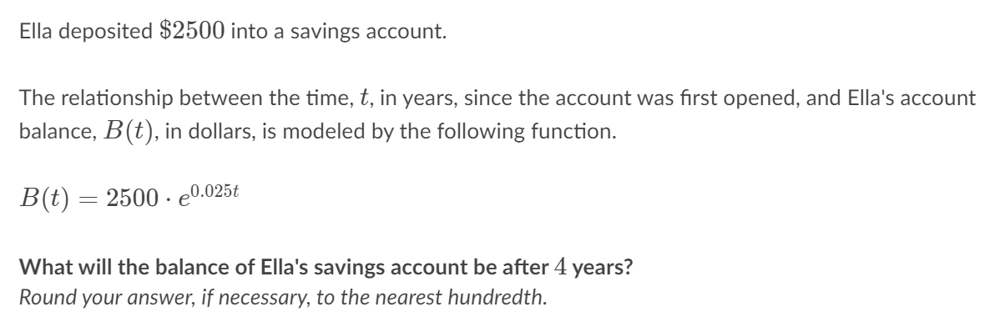

B(t) = 2500·℮0.025(4)

B(t) = 2500·℮0.1 put ℮0.1  into your calculator and you get ≈ 1.1051709

B(t) = 2500·1.1051709 multiply 2500 times 1.1051709

B(t) = 2762.927295 ≈ 2762.93

**EXAMPLE #2**

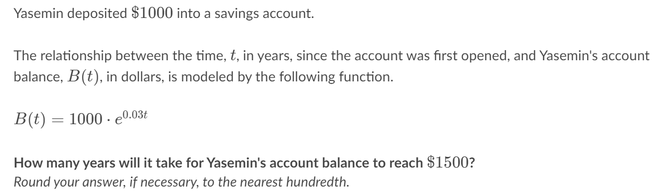

B(t) = 1000·℮0.03t

$1500 = 1000·℮0.03t divide both sides by 1000

1.5 = ℮0.03t change it to a natural logarithm

ln (1.5) = 0.03 t divide both sides by 0.03

ln (1.5) = t

0.03

**EXAMPLE #3**

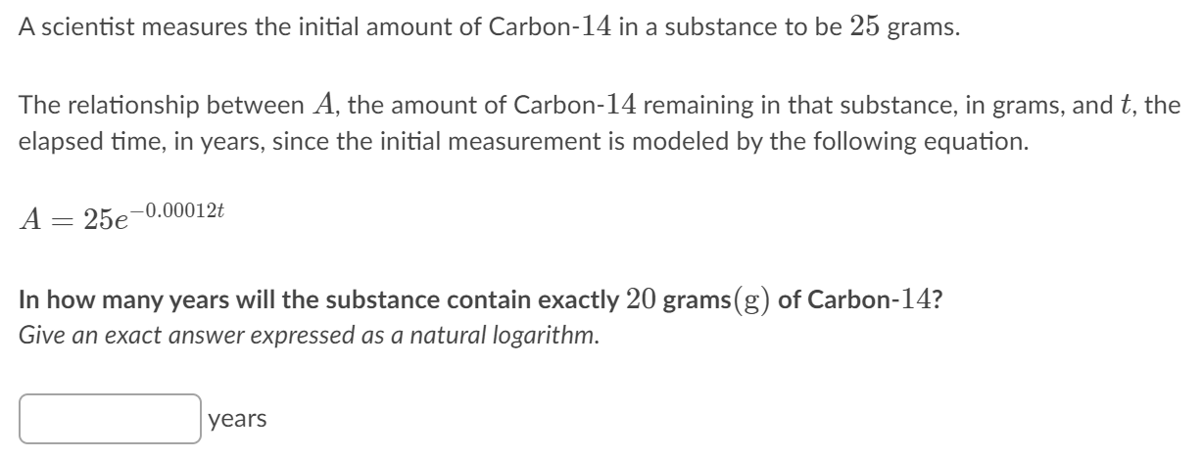

A =25℮ **-**0.00012t

20 =25℮ **-**0.00012t divide both sides by 25

20 =℮ **-**0.00012t 4 =℮ **-**0.00012t

25 5 0.8 = ℮ **-**0.00012t change it to a natural logarithm

Ln 0.8 = t put it into the calculator and you get 1859.5295

-0.00012

**EXAMPLE #4**

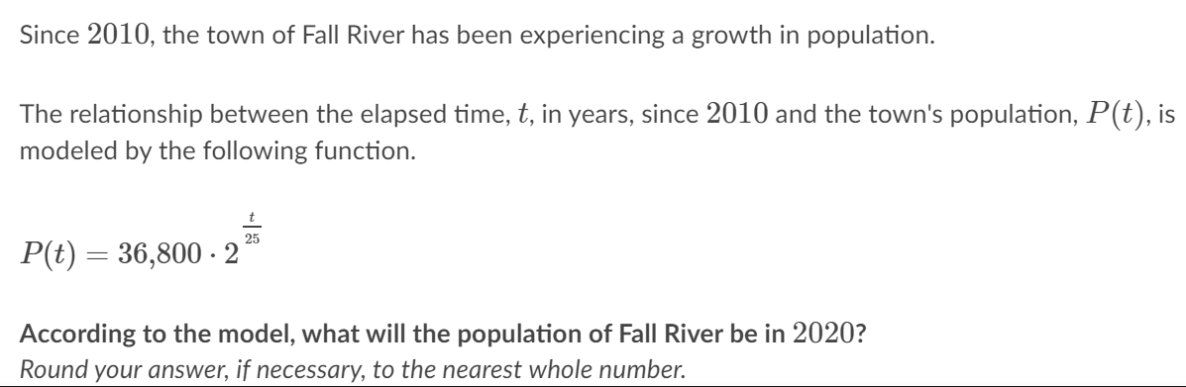

$P\left(t\right)=36800 ∙2^{\frac{t}{25}}$ $P\left(t\right)=36800 ∙2^{\frac{2020-2010}{25}}$

$P\left(t\right)=36800 ∙2^{\frac{10}{25}}$ $P\left(t\right)=36800 ∙2^{0.4}$

put it into the calculator and you get 48557.89 round off to the nearest whole number

48,558 people